Rossmoyne SHS
Mathematics Department
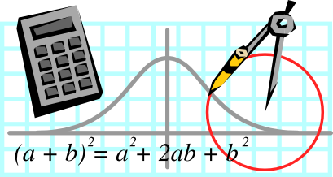

MATHEMATICS 2A B
2010 Examination
Section One: Calculator-Free

STUDENT’S NAME ___________________________________

TEACHER:-
(Circle one name) FLETCHER TANDAY

SOLUTIONS

Time allowed for this section
Reading time before commencing work: 5 minutes
Working time for paper: 50 minutes

Material required/recommended for this section

To be provided by the supervisor
This Question/Answer booklet
Formula sheet

To be provided by the candidate
Standard items: pens, pencils, pencil sharpener, eraser, correction fluid, ruler, highlighters

Special items: nil

Important note to candidates

No other items may be used in this section of the examination. It is your responsibility to ensure that you do not have any unauthorised notes or other items of a non-personal nature in the examination room. If you have any unauthorised material with you, hand it to the supervisor before reading any further.

Structure of this paper

Section | Number of questions available | Number of questions to be answered | Working time (minutes) | Marks available
Section One:  Calculator-free | 6 | 6 | 50 | 40
Section Two:  Calculator-assumed | 13 | 13 | 100 | 80
 |  |  |  | 120

Instructions to candidates

- The rules for the conduct of Western Australian external examinations are detailed in the Year 12 Information Handbook 2010. Sitting this examination implies that you agree to abide by these rules.

- Write your answers in the spaces provided in this Question/Answer Booklet. Spare pages are included at the end of this booklet. They can be used for planning your responses and/or as additional space if required to continue an answer.
- Planning: If you use the spare pages for planning, indicate this clearly at the top of the page.
- Continuing an answer: If you need to use the space to continue an answer, indicate in the original answer space where the answer is continued, i.e. give the page number. Fill in the number of the question(s) that you are continuing to answer at the top of the page.

- Show all your working clearly. Your working should be in sufficient detail to allow your answers to be checked readily and for marks to be awarded for reasoning. Incorrect answers given without supporting reasoning cannot be allocated any marks. For any question or part question worth more than two marks, valid working or justification is required to receive full marks. If you repeat an answer to any question, ensure that you cancel the answer you do not wish to have marked.

- It is recommended that you do not use pencil except in diagrams.

Section One: Calculator-free (40 Marks)
This section has six (6) questions. Answer all questions. Write your answers in the space provided.

Working time for this section is 50 minutes.

Question 1 (4 marks)
(a) Expand and simplify the expression 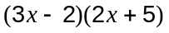 (1 mark)
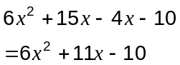

(b) Factorise 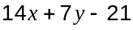. (1 mark)
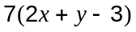

(c) If 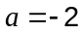 and 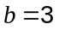evaluate

(i) 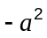 (1 mark)
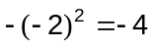

(ii) 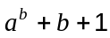 (1 mark)
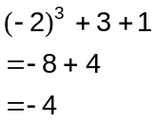

Question 2 (6 marks)
Consider the numbers 8, 3, 5, 7, 2, 9, 2, 3, 5 and 3.

(a) Determine each of the following for the numbers above:

(i) The mean (1 mark)
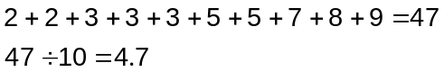

(ii) The mode (1 mark)

3

(iii) The median (1 mark)
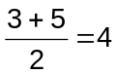

(iv) The range (1 mark)
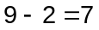

(b) If the largest number is increased by 13, which of your answers to part (a) would change and what would they become? (2 marks)

Mean:
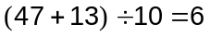

Range:
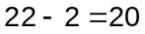

Question 3 (8 marks)
(a) How much is 25% of $60? (1 mark)

$15

(b) Write the number 0.000 007 211 in scientific notation. (1 mark)
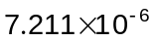

(c) Evaluate 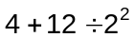 (1 mark)
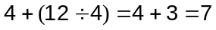

(d) The winner of a $100 000 lottery prize gave one-half of the winnings to charity, kept one-quarter for herself and divided the remainder equally between her two children.

(i) How many dollars did each child receive? (1 mark)
$12 500

(ii) What fraction of the prize did each of her children receive? (1 mark)
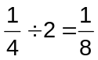

(e) In the game of tennis, a player can either win or lose a match. After a tournament, Ann has a win to loss ratio of 13:6 and Bob has won 70% of his matches.

(i) Determine the simplified ratio of wins to losses for Bob. (1 mark)

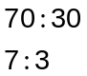

(ii) Compare the win to loss ratios for Ann and Bob and hence decide who the better player was. (2 mark)
Ann's win to loss ratio is 13:6. Bob's is 7:3 = 14:6.
So Bob's ratio is higher, so he is the better player.

Question 4 (8 marks)
Solve each of the following algebraically for the unknown .

(a) 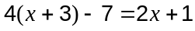 (2 marks)

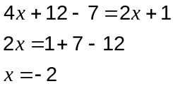

(b) 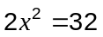 (2 marks)

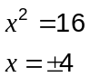

(c) 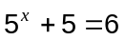 (2 marks)
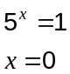

(d) 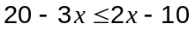 (2 marks)

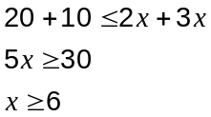

Question 5 (6 marks)
(a) Neatly draw on the grid below a shape which has exactly four lines of symmetry. (1 mark)

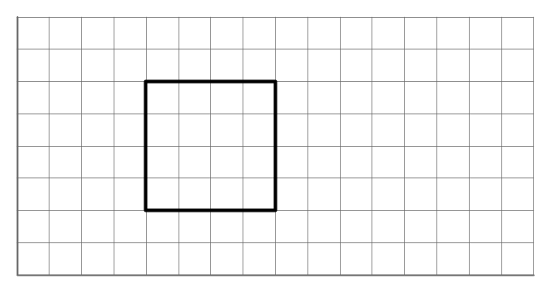

(b) Complete the diagram below so that the resulting shape has rotational symmetry of order two. (1 mark)
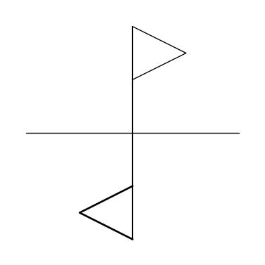

(c) In the space beneath this diagram, describe the single transformation that transforms triangle ABC to triangle PQR. (2 marks)
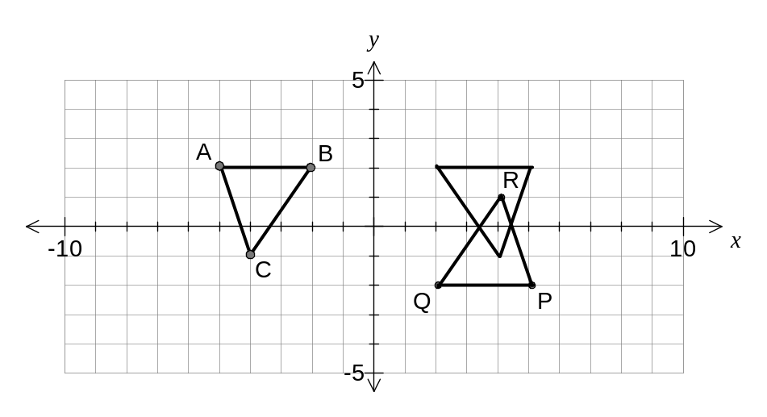
Rotation of 180° about the origin.

(d) On the diagram above, draw the reflection of triangle PQR in the x-axis. (2 marks)

Question 6 (8 marks)
(a) Two linear functions are given by 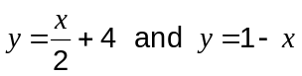. The point A(2, 5) lies on one of the lines but not the other. Show this algebraically. (2 marks)

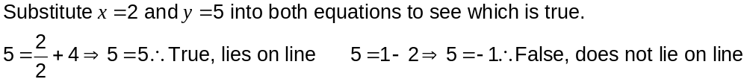

(b) Plot the points A(2, 5) and B(-3, 0) on the axes below and then draw a straight line through them. (1 mark)
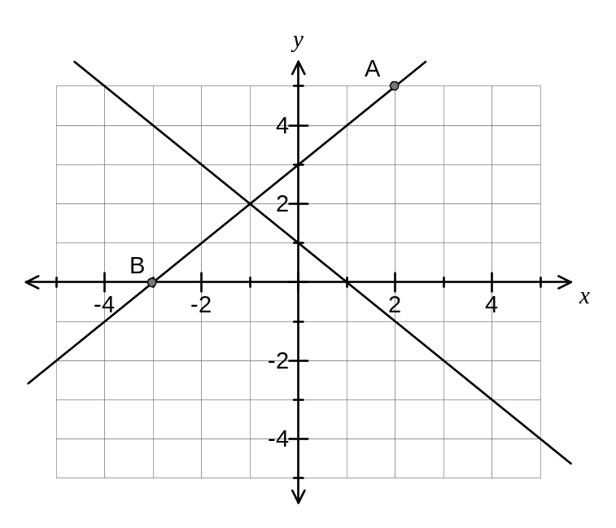
(c) Determine the rule for the linear function passing through points A and B. (2 marks)

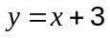

(d) Graph the function 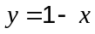 on the above set of axes. (2 marks)

(e) From the graph, state the coordinates of the point of intersection of the line passing through A and B and the line . (1 mark)

(-1, 2)

Additional working space

Question numbers(s):

Additional working space

Question numbers(s):
Additional working space

Question numbers(s):

